Common Infectious Horse Diseases
Drs. Foster & Smith Educational Staff
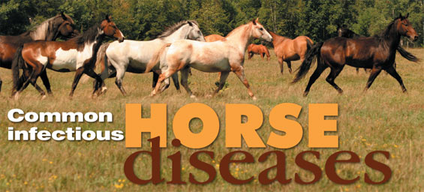
Knowledge is the key to disease prevention
Infectious diseases are those diseases that horses can get from each other, or via a vector, such as a mosquito, which may transmit the disease from horse to horse. Horse owners can vaccinate their horses against many of these diseases, or their veterinarian may administer the vaccinations.
Some vaccines are considered "core" vaccines that cover diseases that all horses need to be immunized against. Some horses may need to be immunized only when there is significant risk that they will be exposed to the disease in their natural environment, or if they may be exposed when traveling, showing, or competing. In addition, horses must be vaccinated at different life stages. Most vaccines need to be given annually. See our Vaccine Schedule to check when your horse needs these immunizations.
Tetanus (lockjaw)
Tetanus is caused by a bacterial toxin normally found in the soil and in the feces of horses. The bacteria that produce the tetanus toxin need a decreased oxygen supply to multiply, so any area where there is a deep puncture wound or where a wound has healed over (such as the navel stump of a newborn foal) is an area where tetanus can thrive. Symptoms of tetanus include an elevated third eyelid and stiff neck, progressing to overall muscle stiffness causing a 'sawhorse' stance. Tetanus is often fatal, but a yearly vaccine can prevent it, and the vaccine is a good idea because small cuts can go unnoticed and become infected.
Equine Encephalomyelitis (sleeping sickness)
This is a disease that affects the nervous system, and can be caused by equine encephalomyelitis viruses (Eastern, Western, and Venezuelan), which are carried by mosquitoes. Signs include depression and a high fever, followed by a period when the horse appears blind, nervous and uncoordinated, which progresses to muscle tremors, yawning, and eventually, complete paralysis. Proper vaccination and good mosquito control are important to help prevent this disease.
Equine Influenza
This viral disease is spread by inhalation of drops of infective material. Signs include a dry, hacking cough, sudden onset of fever, watery nasal discharge, weakness, stiffness, loss of appetite and depression. Infection with equine influenza is rarely fatal but can cause problems such as emphysema, pneumonia or bronchitis.
Equine Herpesvirus (rhinopneumonitis, rhino, viral abortion)
There are 2 types of equine herpesvirus: EHV-1, which causes respiratory disease (fever, cough, nasal discharge), reproductive problems (abortion, stillbirth), and neurological problems (hindlimb weakness, difficulty walking, sometimes paralysis); and EHV-4, which just causes respiratory problems and is usually only a problem in younger horses. Once a horse has been infected with EHV-1, he will always be a carrier, and the virus may re-activate within the horse during times of stress. A horse that has been infected with EHV-4 will always test positive for it also, but usually will not show clinical signs of it again after the initial infection.
West Nile Virus
Horses get WNV by being bitten by an infected mosquito; most horses do not show any signs and recover on their own, but in some horses the infection affects the central nervous system and causes signs including fever, weakness or paralysis of the hind limbs, impaired vision, lack of coordination, head pressing, convulsions, inability to swallow, and coma.
Rabies
This is a viral infection of the central nervous system, and although it is not common in horses, rabies can be transmitted to horses by the bite of an infected animal such as a skunk, raccoon, fox, dog or bat. Rabies can be transmitted to people. We recommend that you check with your veterinarian regarding recommendations for rabies vaccination for your horse.
Strangles (shipping fever)
This contagious respiratory disease is caused by a bacterial infection. Signs include a fever, thick, yellow, nasal discharge and swollen, abscessed lymph nodes under the jaws. The infection is spread by infected material from nasal discharge or abscesses contaminating stalls, feed troughs, pastures, etc. Young horses are the most susceptible to strangles and many horses seem to have a lifetime immunity after recovering from this disease.
Potomac Horse Fever
This disease is a bacterial infection of the blood and tissues and is thought to be transmitted to horses by arthropod vectors such as ticks, lice, mites, and fleas. It is much more common in some areas of the country than others. Signs include a high fever, depression, decreased gut sounds, and a profuse, watery diarrhea that can lead to laminitis, colic, dehydration, shock, and death.
Another common horse condition are worms, although not technically a disease, they are parasites. Please see our common internal parasites article for more details about worms.

